Select:

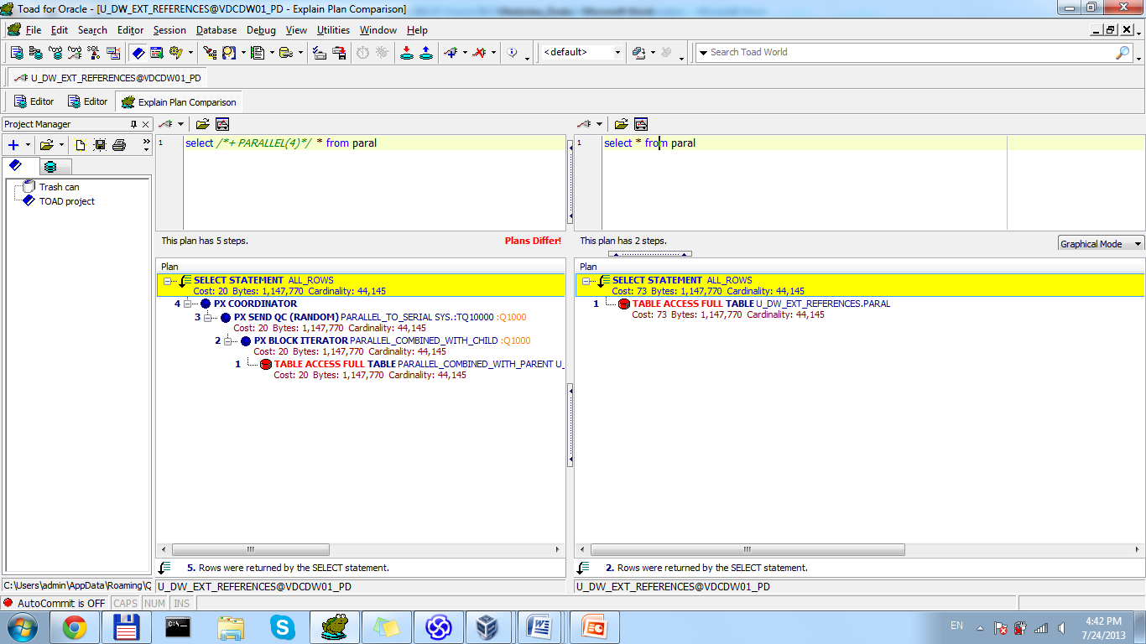

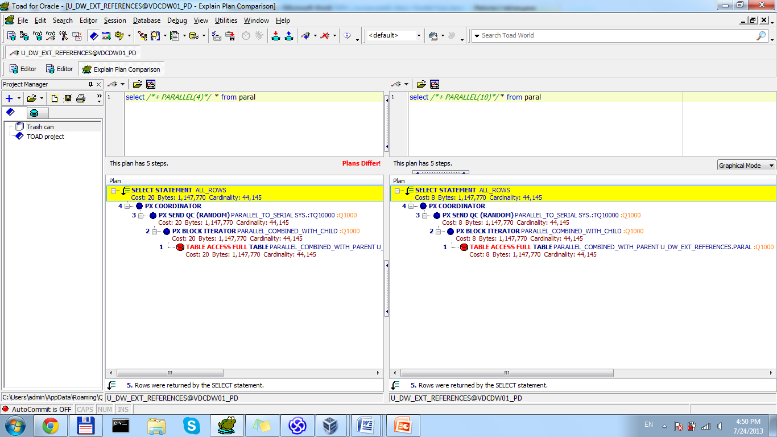

|  |  |
| --- | --- |
| Amount of parallel process | Time, msec |
| 1 | 178 |
| 4 | 455 |
| 10 | 1000 |

DML

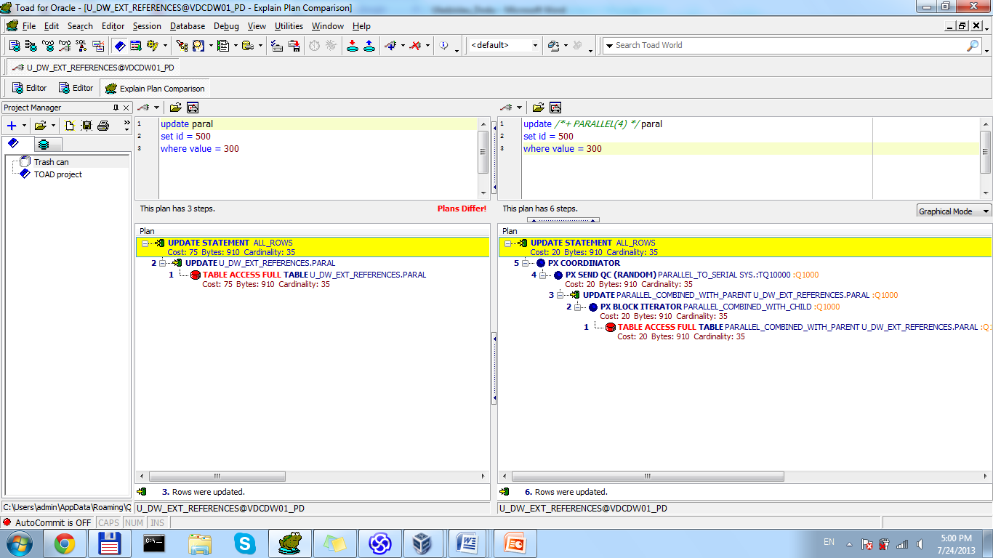

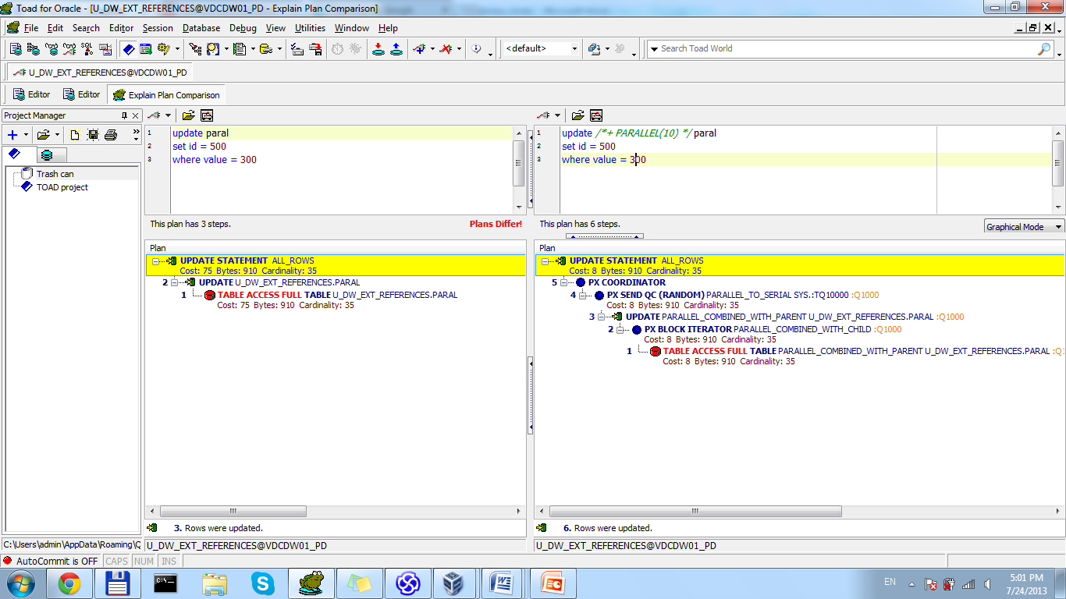

|  |  |
| --- | --- |
| Amount of parallel process | Time, msec |
| 1 | 83 |
| 4 | 483 |
| 10 | 3000 |

DDL:

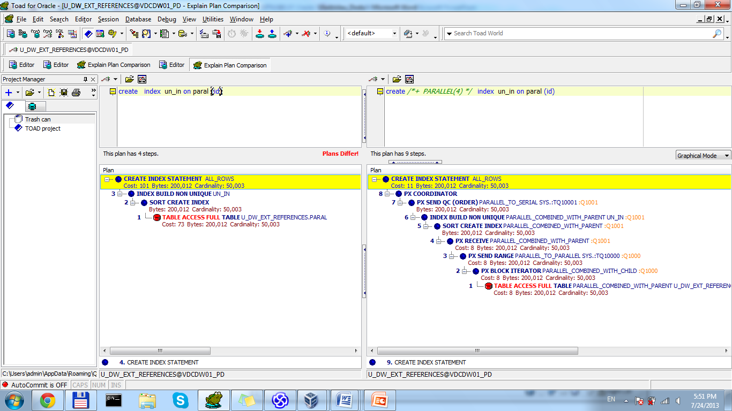

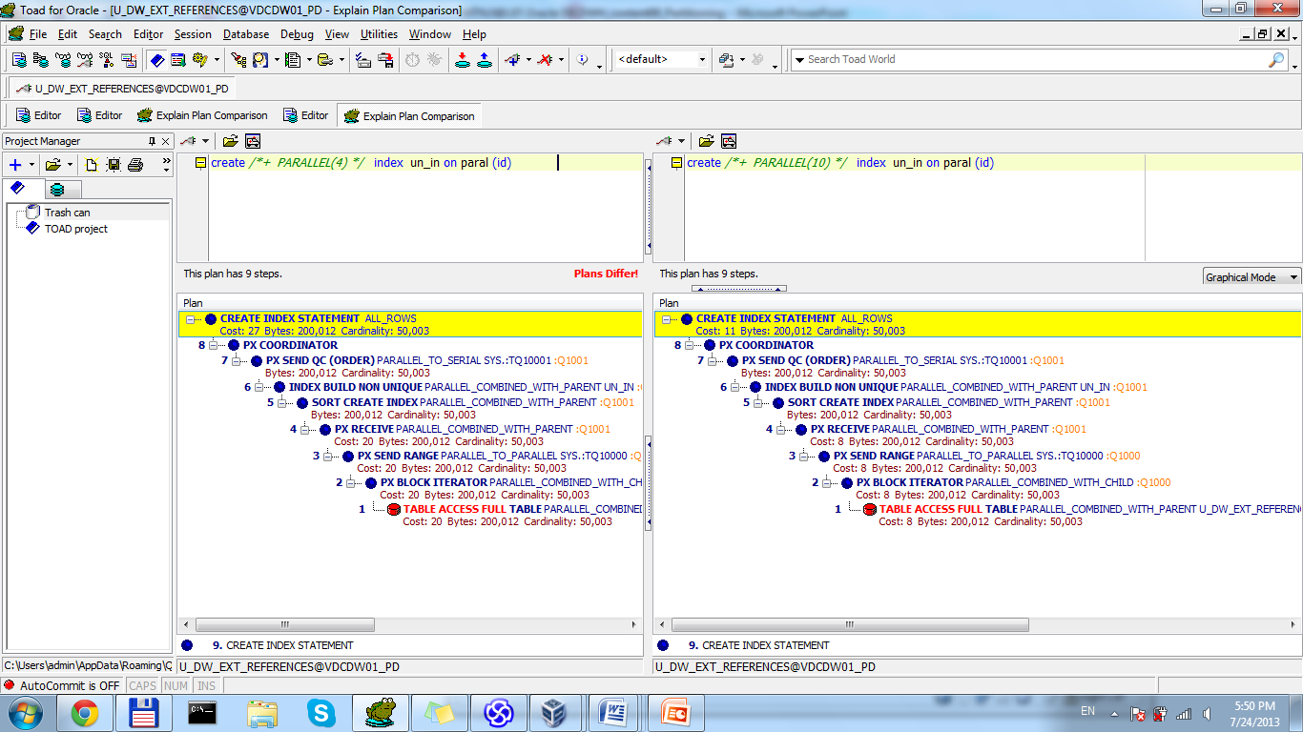

|  |  |
| --- | --- |
| Amount of parallel process | Time, msec |
| 1 | 719 |
| 4 | 2000 |
| 10 | 9000 |